# **Pool maintenance and testing**

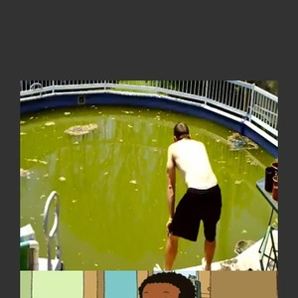

The goal of every pool and spa owner is to have sparkling, clean water. Unfortunately, a variety of undesirable substances will often enter a pool or spa. A pool can quickly become contaminated by oral and nasal discharges, skin shedding, sweat, urine, and occasionally faecal matter. A number of pathogenic and other microorganisms will accumulate, especially on the water surface where mucus has a tendency to gather. The most common health issues are eye, ear, nose, and throat ailments; infections of skin lesions; and enteric and urinary tract infections. Spa pools have a greater release of body fats into the pool because of higher temperatures.

Where water is treated and water quality maintained properly there is a low risk of cross-infection.

Interesting fact: A pool user can lose up to one litre of sweat per hour when actively swimming in water at 24 degrees Celsius.

## Free available Chlorine and Total Chlorine

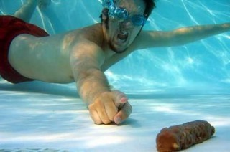To get good quality water in a pool the use of a sanitizer, such as chlorine is inevitable.

Free available chlorine (FAC, the chlorine you test for when you do the standard pool test with a DPD1 tablet) in pools is destroyed rapidly by Sunlight but also by the contaminants mentioned above.

When chlorine enters the water, it is in the “Free Available Chlorine” form that is an active sanitizer and an oxidizer called (FAC). It will react with any number of contaminants in the water. When it reacts with ammonia compounds in the water, which come from bathers’ perspiration and urine, it becomes “combined chlorine”. In this form, chlorine is a much slower sanitizer.

This form also causes chlorine odour and eye irritation. When the *total chlorine* reading is higher than the free chlorine reading (FAC), it is time to oxidize or destroy the *combined chlorine*. The simplest way is to increase the chlorine level in the pool to 10 ppm (parts per million). This higher level of chlorine will oxidize or eliminate the combined chlorine and is called super-chlorination or shock treating.

Free available chlorine should be between 2.5 and 5.0mg/L (milligrams per litre).

Interesting fact: Chlorine is not particularly effective against protozoa such as Giardia and Cryptosporidium

## Bromine

Bromine is also a sanitizer and disinfects the water just like Chlorine does but is less effective when pH levels are too low or too high. The ideal bromine level (see picture left) 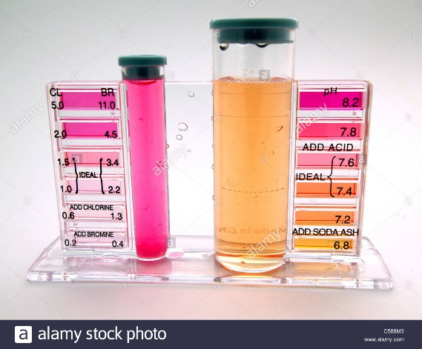should be between 5.0 and 7.0mg/L for spa pools. *Note if you use a chlorine test kit you need to multiply the reading by 2.2 for total bromine*.

Bromine is naturally acidic and therefore the pH level will continuously need to be adjusted up.

Bromine has only half the disinfectant power of Chlorine and therefore twice as much must be added to the pool to achieve similar disinfection rates.

## Salt water Pool

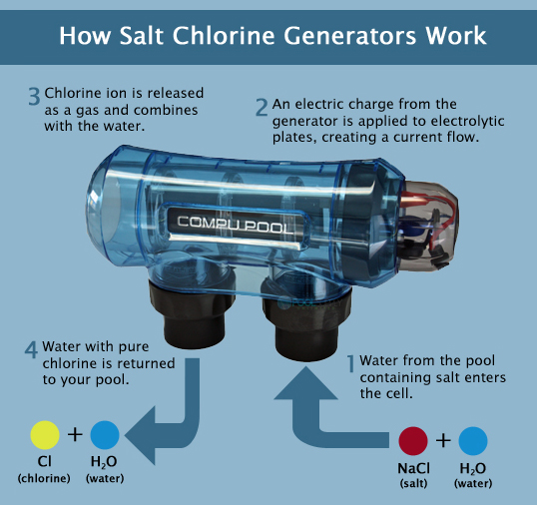Salt water pools work on a system where dissolved salt in water is converted to chlorine in a salt cell generator.

The salt system or generator is installed on the pressure side back by the filtration system of the pool. This salt generator basically consists of a control box and a salt cell. The salt cell has metal plates in it which are connected to the control box. The control box sends an electrical charge to the plates which creates chlorine through a process called electrolysis. As pool water passes through the salt cell, the salt in the water is turned into Hypochlorous acid. Hypochlorous acid is the same component that is produced when any chlorine is added to pool water, whether you use sticks, tablets, granular or liquid. As the water returns to the pool, it will introduce the newly produced chlorine.

A salt water pool is also a chlorine pool because even though you are putting no chlorine into the pool the end result will be chlorine that is produced from the salt generator.

The chlorine that is produced in a salt water pool is a non-stabilized type. The salt system produces only this type of chlorine that usually creates a very high pH level. The pH balance is important in maintaining water clarity as well as the preserving the integrity of some of the materials used in the building the pool.

So in order for the pool to operate most efficiently and effectively the salinity (amount of salt in water) should be within a certain range (25000 – 4500ppm). If the salinity in the pool is low it will mean the generator cannot produce the amount of chlorine the pool needs to stay sanitised.

In other words even though you can have the generator set to 100% but your Free Available Chlorine test shows no or little chlorine, you will have to ask yourself three questions;

1. Is there enough salt in the pool? Unless there is enough salinity it cannot be converted to chlorine.
2. Is there calcium build up on the salt cell (inside the generator) which minimises is effectiveness.
3. Is there enough pool water circulating through the cell? Air in the system due to low pool levels or a blocked filter can significantly decrease the cells effectiveness.

Salt pools lose salt through adding more water to the pool (diluting), due to low levels caused by splash out, or by rain water being added.

## Stabilizing free available chlorine (FAC) with Cyanuric acid

In an outdoor swimming pool, the use of a chlorine stabilizer (cyanuric acid) is usually recommended to reduce the degradation of free chlorine by sunlight. Cyanuric acid acts like a shield for chlorine from ultraviolet light. It binds to free chlorine and releases it slowly, extending the time needed to deplete each dose of sanitizer. It can be added by itself, usually at an initial dose of 30-40 ppm (parts per million).

Cyanuric acid only dissolves slowly and to a limited extent in water. It is best added to the balance tank (where water flows into the grate) with a mesh bag where it can dissolve slowly.

The ideal cyanuric acid level should be between 30 – 60mg/L

## pH levels

pH is the measure of the acidity of the water. The pH scale extends from 0 to 14 with 7 being neutral. As the pH moves lower than 7.0, the water becomes more acidic and tends to be corrosive (metal starts to rust); as pH moves up higher than 7.0, the water becomes less acidic (or more basic) and could lead to a scale forming condition and an increase of the micro bacterial level in the pool. Since most water has the tendency to either corrode or leave small, crusty “scale” deposits, it is important to properly balance the factors of pH, total alkalinity and hardness. Depending on where you live, the water can contain a variety of minerals. These minerals directly affect whether the water will corrode, scale or be in balance. In addition to pH, total alkalinity, calcium hardness, and temperature plays a role in water balance.

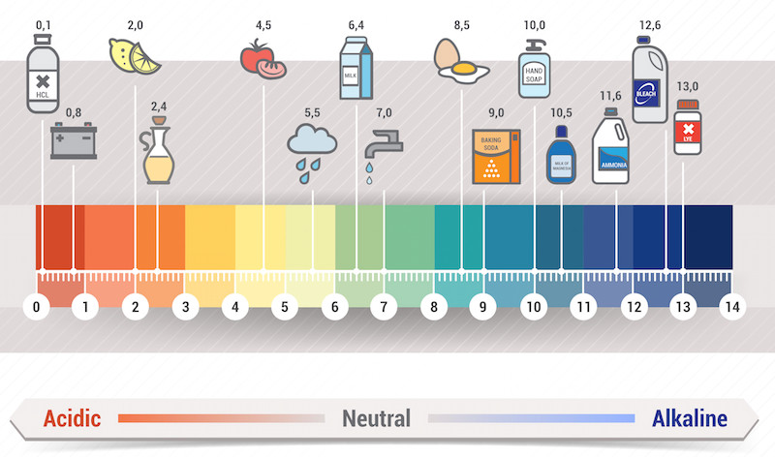

Note: a high pH level (above 7.8) will inhibit the ability of free chlorine to sanitize water efficiently. Ideal pH should be between 7.2 and 7.8.

## Total Alkalinity

Total alkalinity refers to how well pool water can resist changes in the pH. If the alkalinity is too low, the pH could potentially change daily. This is known as “pH bounce” and leaves the pool and spa water vulnerable to pH problems from chlorine treatments, environmental conditions and even from fresh make-up water. Low alkalinity water will tend to be corrosive, thus eroding pool surfaces and equipment.

If the alkalinity level is too high, the pH may also drift to a very high level. Then, it is very difficult to reduce the pH and the water may be cloudy and prone to scaling.

The ideal alkalinity range for a pool or spa is 80 – 120 ppm (100 – 150 if using cyanuric acid)

# http://www.purfresh.com/images/im_o3_how_it_works.jpgOzone disinfection

Ozone is used as a secondary disinfectant to disinfect contaminants in pool water. Ozone is a poisonous gas, and if it is not properly stripped from the water before recirculation, the off-gassing of ozone is a potential hazard to the health of bathers.

Ozone gas is produced by passing dry air or oxygen through a series of electrodes where the oxygen is converted to ozone.

Ozone does not last long in water. The primary disinfectant, chlorine, which has a longer lifetime, has to be added after ozone to kill any microorganisms that enter the pool water during use. Under optimum conditions ozone will destroy protozoa such as Giardia and Cryptosporidium.

Apart from Ozone, Ultra Violet light is also used in addition to bromine and chlorine to disinfect pool water.

## Pool testing

Pool testing should be done according to the NZ pool standard every three hours in public pools (prior to daily use and then every three hours). However local circumstances need to be taken into account such as participant numbers, and at what time the pool is used by groups.

Pool samples should be taken from the middle point of where water enters the pool and exits the pool, at a depth of 300mm. This is done by holding the test kit tube upside down and taking it to a depth of 300mm before turning it the right way up.



Care needs to be taken to not touch the tablets such as DPD1- 3, and Phenol red with your fingers (for example you should not hold your fingers over the ends of the test tubes to agitate the sample water).

Note: Really high Chlorine levels can alter the test appearance of pH. In other words if your chlorine reading is really high get it back to a normal level before you check the pH level.

Spot the difference; Bromine versus Chlorine (spa pool versus pool)

**Test Chart**

|  |  |  |  |  |
| --- | --- | --- | --- | --- |
| Characteristic or chemical | Lowest value | Highest value | Most desirable value | Notes |
| pH | 7.2 | 8.0 | 7.4 – 7.6 | Too low: plaster and  concrete etching, eye  discomfort, corrosion of  metals, and vinyl liner  damage, could occur  Too high: Low chlorine  efficacy, scale formation,  cloudy water, and eye  discomfort could occur |
| Alkalinity | 50 mg/L | 200 mg/L | 60 – 120 mg/L | Too low: pH bounce, corrosion tendency  Too high: Cloudy water, increased scaling, pH tends to be too high. |
| Calcium hardness | 40 mg/L | 300 mg/L |  | Too low: Etching and corrosion  Too high: Scaling and cloudy water |
| Free available chlorine (FAC):  Swimming pool:  Chlorine alone  Chlorine + other | 1.5mg/L  0.5mg/L | 7.0mg/L  5.0mg/L | 2.5 – 5.0mg/L | A heavy pool bathing load require operation at near maximum levels.  Chlorine + other means; Chlorine plus ozone, UV, or CIO² |
| Total Bromine:  Swimming pool  Spa pool | 4.0mg/L  4.0mg/L | 10.0mg/L  10.0mg/L | 4.0 – 6.0mg/L  5.0 – 7.0mg/L | For both swimming pools and spa pools: if using a chlorine test kit multiply the reading by 2.2 for total bromine. |
| Cyanuric acid | 25mg/L | 100mg/L | 30 – 60mg/L | Too low: Chlorine residual rapidly destroyed by sunlight  Too high: Reduces the chlorine efficacy |

## Frequency of testing

|  |  |  |
| --- | --- | --- |
| Test | Frequency | Notes |
| pH | Prior to use then every three hours |  |
| Alkalinity | weekly |  |
| Calcium hardness | Monthly |  |
| Free available chlorine/ bromine | Prior to use then every three hours |  |
| Total chlorine | Daily | Combined available chlorine is calculated by subtracting measured free available chlorine (FAC) from measured total chlorine. |
| Cyanuric acid | At beginning of season, then fortnightly |  |
| Chloride if saline pool water is electrolysed | At beginning of season, then weekly |  |
| Total dissolvent solids (TDS) | At beginning of season, then weekly |  |

# **Other factors that should be considered**

### Metals

The levels of metals in water are monitored to avoid coloured water and stains on pool or spa surfaces. Since stains from dissolved metals are troublesome to remove, most pool professionals like to test for at least copper and iron in the spring or several times a year as a precaution.

Copper will tend to stain surfaces (including hair) blue-green and can cause water to become a tint of aquamarine after a high chlorine dosage.

Iron can leave stains of a brown or rusty colour and can turn water green or brown following a chlorine dose. Manganese is much rarer than copper or iron, but can leave behind blackish specks on the walls and components.

### Nitrate and Phosphate

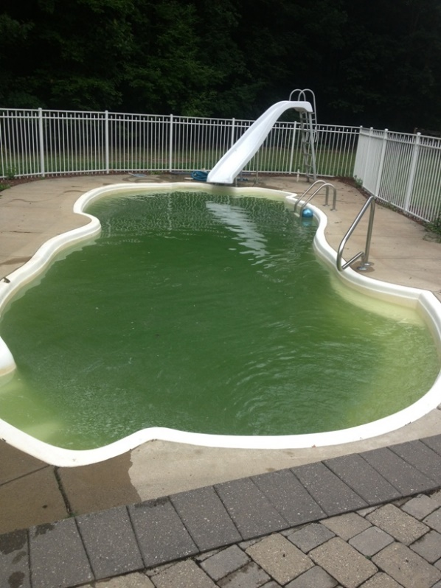The combination of nitrate and phosphate is the building block for algae. Fortunately, if one is eliminated the other cannot produce algae on its own. Large amounts of nitrates can cause other problems, such as increases in chlorine demand.

For example, an enormous amount of chlorine is added in the morning, and is gone by the afternoon. This occurrence is more common in seasonal pools that have just been reopened because nitrates can enter the water from leaves or debris that were recently removed. Other sources of nitrate intrusion come from well water supplies and localized spraying of garden or crop fertilizers.

Since nitrates can only be removed by draining the water, some manufacturers have focused on removing the other algae nutrient, phosphate. A variety of phosphate removal systems have been introduced to eliminate the potential for algae. Phosphates can enter the water from municipal water supplies (where they are used for corrosion and metal control) and from some forms of metal sequestering agents (as the organic phosphate called phosphonate breaks down to ortho-phosphate). By maintaining a constant level of 1.0 ppm or higher of free chlorine in the pool or spa, algae should normally not be a problem.

### Algae

|  |  |  |  |
| --- | --- | --- | --- |
| Colour | Green algae | Black algae | Mustard algae |
| Appearance | Pea green colour. Sometimes colours entire body of water. Also attaches to pool surfaces | Better known as “black spots” on pool walls and surfaces | A yellow film usually found on steps and walls. |
| Causes | Insufficient or inactive levels of sanitizer. Inadequate water circulation. High nitrate and phosphate levels. | | |
| Treatment | 1.Check pH and adjust if necessary | 1.B rush affected areas thoroughly | 1. Brush affected areas thoroughly |
|  | 2.Shock treat pool water | 2. Spot treat affected areas with sanitizer | 2. Spot treat affected areas with sanitizer |
|  | 3.Brush surface areas if necessary | 3. Shock treat pool water and later add algaecide. | 3. Shock treat pool water or use a specialised mustard algae treatment. |
|  | 4.Retest pH and repeat treatment if necessary | 4. Brush and vacuum as necessary | 4. Retest pH and repeat treatment if necessary |

### Cloudy water

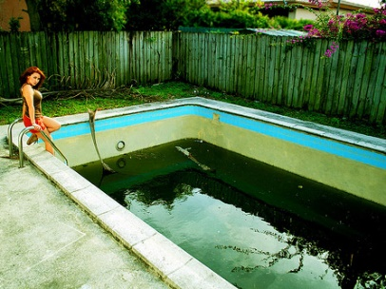Cloudy pool water is an unfortunate, but common problem in swimming pools. The usual causes of poor water clarity are improper filtration, and/or improperly balanced water. An algae condition, or severe chloramine condition can cause cloudy pool water.

If the water is cloudy, the operator should first check the filter system. If backwashing does not decrease pressure to the normal operational level, the filter may need cleaning. Inspect the sand in the sand filter for clumps or air pockets. Consult your local professional if you are not familiar with filter maintenance.

### Eye and Skin irritations

Eye and skin irritations are another common problem for swimming pool bathers. In addition to such irritations within the water, nasal irritations can also be noticed in indoor pool areas with poor ventilation and excessive levels of combined chlorine, also known as chloramines.

There are two basic causes of eye and skin irritations: improper pH and high chloramines. The human eye is most comfortable in water with a pH of about 7.5. Therefore a low pH, below 7.2, or a high pH, above 8.0 can become quite irritating.

A chloramine problem is caused when combined chlorine levels exceed 0.2 ppm. Though many people incorrectly blame high chlorine for stinging eye irritations, it is actually the presence of chloramines.

## Water treatment tables and calculations

Chemical adjustments are vital to proper sanitation and water balance. Since adjustments are based on the volume of water in the pool or spa, it is important to calculate the volume correctly. The following formulas may be used:

### Rectangle pool volume

**Main pool (Metric Units):**

Length = 25m

Width = 10m

Avg. depth = 1.5m

Volume = (length x width x average depth x

1,000)

25 x 10 x 1.5 x 1,000 = 375,000 litres

**Lowering pH with Dry Acid (Sodium Bisulphate) to 7.5**

|  |  |  |  |  |  |  |  |  |  |
| --- | --- | --- | --- | --- | --- | --- | --- | --- | --- |
| Starting from | | Spa pool  24.000L | | | Village Pool  60.000L | | | Main pool  375.000L | |
| pH | Kg | | g | Kg | | g | Kg | | g |
| 7.6 – 7.8 |  | | 240 |  | | 660 | 3 | | 400 |
| 7.8 – 8.0 |  | | 360 |  | | 780 | 4 | | 840 |
| 8.0 – 8.4 |  | | 480 | 1 | | 20 | 5 | | 800 |
| * 8.4 | 1 | | 440 | 1 | | 620 | 7 | | 240 |

Notes: Treatment recommendations are affected by total alkalinity. At low alkalinity levels less acid may be required and at higher alkalinity levels more acid may be required.

**Raising pH with Soda Ash to 7.5**

|  |  |  |  |  |  |  |  |  |  |
| --- | --- | --- | --- | --- | --- | --- | --- | --- | --- |
| Starting from | | Spa pool  24.000L | | | Village Pool  60.000L | | | Main pool  375.000L | |
| pH | Kg | | g | Kg | | g | Kg | | g |
| 7.2 – 7.4 |  | | 96 |  | | 288 | 1 | | 632 |
| 7.0 – 7.2 |  | | 144 |  | | 432 | 2 | | 448 |
| 6.8 – 7.0 |  | | 192 |  | | 576 | 3 | | 264 |
| < 6.7 |  | | 240 |  | | 720 | 3 | | 864 |

**Adjusting Cyanuric acid**

|  |  |  |  |  |  |  |  |  |
| --- | --- | --- | --- | --- | --- | --- | --- | --- |
| To raise ppm by | Spa pool  24.000L | | | Village Pool  60.000L | | | Main pool  375.000L | |
| Kg | g | Kg | | g | Kg | | g |
| 10 | n/a | | 0 | | 600 | 3 | | 400 |
| 20 | 1 | | 200 | 6 | | 800 |
| 3.0 | 1 | | 800 | 10 | | 200 |
| 40 | 2 | | 400 | 13 | | 600 |
| 50 | 3 | | 0 | 17 | |  |

# Swimming pool maintenance H & S

### Safety around chlorine agents

There are two main types of chlorinating agents:

Inorganic chlorinating agents such as calcium hypochlorite, lithium hypochlorite, sodium hypochlorite, and

Organic chlorinating agents such as trichloroisocyanuric acid, potassium dichloroisocyanurate, sodium dichlorocyanurate [as anhydrous or dihydrate forms].

Organic and inorganic chlorinating agents are not compatible with each other. Many incidents occur when the same scoop or pail is used for both chemicals without cleaning them or when adding one product after the other or in the pool chlorinator. Mixing or cross-contamination of these chemicals can form an explosive mixture.

### Chemical storage

Swimming pool chemicals can also be oxidizers and corrosives.

Oxidizing materials (such as calcium hypochlorite which we use at camp)) have the ability to react chemically to oxidize combustible (burnable) materials. To be an "oxidizer", the material itself provides oxygen which combines chemically with another material in a way that increases the chance of a fire or explosion. This reaction may be spontaneous at either room temperature or may occur with slight heating. Thus, oxidizing liquids and solids can be severe fire and explosion hazards.

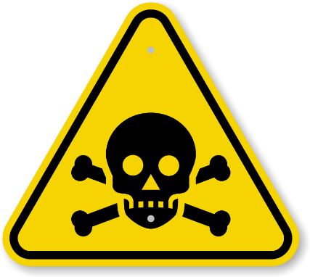Some pool chemicals can also be corrosive. Corrosives are materials that can attack and chemically destroy body tissues on contact. Corrosives can also damage or destroy metal. The effects on tissues and metals depends on what the corrosive agent is and how concentrated it is. They can begin to cause damage as soon as they touch the skin, eyes, respiratory tract, digestive tract, or the metal. MSDSs or product labels should be consulted for the specific effects on tissues or metals and for procedures to follow in cases of spills or splashes. For more information about how to work safely with corrosive chemicals or materials, please see the Corrosive Materials section.

### Do’s

* Keep all chemicals out of the reach of children and pets.
* Containers should always be kept closed when not in use.
* Use separate, clean metal or plastic measuring cups for each chemical to transfer or measure chemicals. (Scoops should not be made of wood.)
* Wear appropriate protective equipment and clothing including goggles, gloves and footwear.
* Protect chemicals from moisture and water - such as a cup of water (or coffee!). Even putting the wet scoop back into the pail may cause a reaction.
* Always add the chemical to the pool water - never the other way around (never add water to the chemical) unless instructed to do so on the container label.
* Wash your hands thoroughly after handling any chemicals.
* Use or handle chemicals in well ventilated areas only.
* Store chemicals in a cool dry place away from sunlight

### Do not

* Do not use contents of unlabelled containers.
* Do not mix different chemicals together.
* Do not put spilled chemicals back into their containers.
* Never store oxidizers or acids next to each other
* Do not store liquids above dry chemicals
* 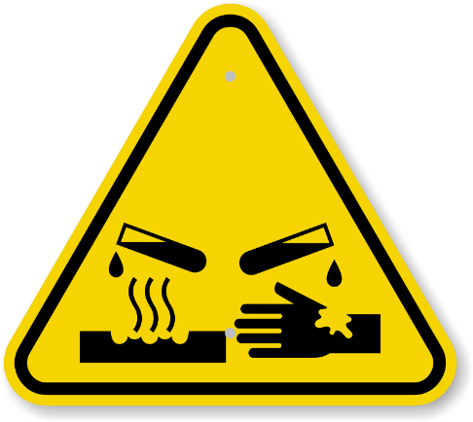Do not store pool chemicals near gasoline, fertilizers, herbicides, grease, paints, tile cleaners, turpentine, or flammable materials. This tip is especially important when pool chemicals are stored in sheds or small storage rooms.
* Avoid touching the undiluted chemicals with your hands.
* Do not smoke when handling chemicals.
* Do not expose to heat or flame.
* If a fire breaks out, **do not** use a "dry chemical" fire extinguisher. Only use large amounts of water. If you cannot extinguish the flame immediately, leave the area and call the fire department.
* Do not leave pool shed unlocked